**Test Case 0007**

**System:** VirtuCardsHost, VirtuCardsClient

**Description:** Tests that the host application creates rooms in Photon with unique codes. **Severity:** 1

**Instructions**

**Test 1 – Room Code generation**

1. Start an instance of the VirtuCardHost application.
2. Sign In to the application.
3. Click the Create Room button.
4. The VirtuCardHost application will now display a waiting screen that lists the Photon Room Code.

**Expected result:** The waiting screen should depict a Room Code in the top of the screen. The Room Code should be in the format of six capital English letters. There should be no special characters (?”!@#$%^&*<>:;) and no numbers in the Room Code.

**Test 2 –** **Photon Room Creation**

1. Start an instance of the VirtuCardsHost application.
2. Sign In to the application.
3. Click the Create Room button.
4. The VirtuCardsHost application will now display a waiting screen that lists the Photon Room Code. It should be in the form of a string of six capital English letters.
5. Select a Game Mode
6. Note the displayed Room Code.
7. Start an instance of the VirtuCardsClient application.
8. Sign In to the application (with any credentials even the ones used to sign-in to the host are fine).
9. Enter the noted Room Code into the ‘*Enter Code’* field and press Join.
10. The VirtuCardsClient should now show a waiting screen and the VirtuCardsHost application should reflect the Client in the players list.
11. Press Start game in the Host application.

**Expected result:** The VirtuCardsHost application and VirtuCardsClient application should transition into a session of the desired game. If the UI doesn’t change to depict the aforementioned change, then the application isn’t functioning as per requirements.

**Test Case 3 – Room Creation with multiple players**

* + - 1. Repeat steps 1-6 from Test 3 on the VirtuCardsHost application.
      2. Repeat steps 7-10 on 4-5 different instances of the VirtuCardsClient with different Sign In credentials.
      3. Press the *Start Game* button on the VirtuCardsHost application.

**Expected result:** The VirtuCardsHost should now reflect all the Clients in the Player list. After pressing the *Start Game* button, the VirtuCards applications should now reflect a session of the selected game with all the clients involved in the game.

**Test 4 – Unique Code generation**

1. Start an instance of the VirtuCardsHost application.
2. Sign In to the application.
3. Click the Create Room button.
4. The VirtuCardsHost application will now display a waiting screen that lists the Photon Room Code. It should be in the form of a string of six capital English letters.
5. Note the displayed Room Code.
6. Press the arrow acting as the back button.
7. Click the Create Room button again.
8. The VirtuCardsHost application will now display a waiting screen that lists the Photon Room Code. It should be in the form of a string of six capital English letters.
9. Note the new displayed Room Code.
10. Evaluate whether the two noted Room Codes are identical or not.

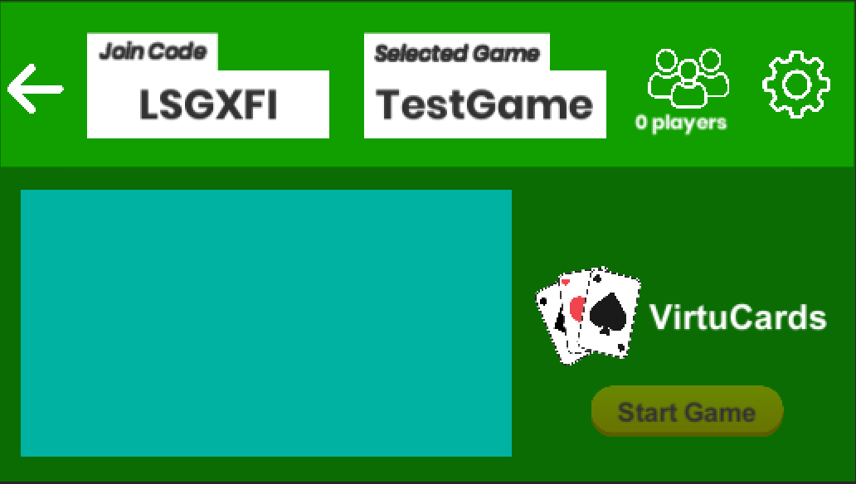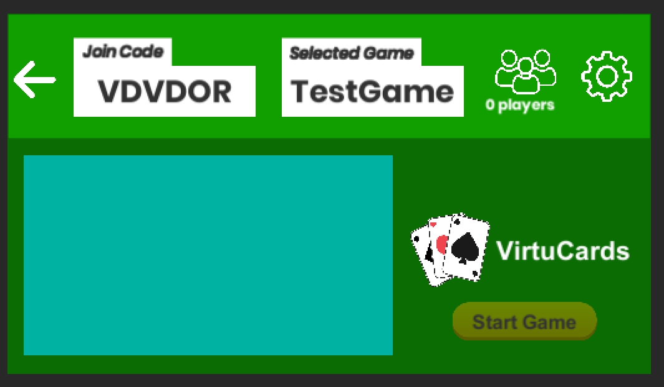**Expected result:** The two noted Room Codes should not be identical.